Model 259
TEMPERATURE CONTROLLER
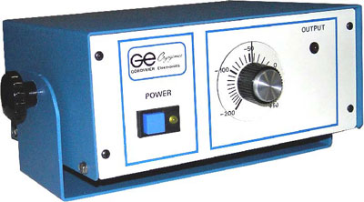
The Model 259 is a temperature controller which is used as a basic "ON" - "OFF" controller.
When installed, the Model 259 will maintain systems at cryogenic temperatures, with the use of a single thermocouple sensor in conjunction with a valve.

