Model 269
AUTOMATIC SHUT-OFF LN2 CONTROLLER
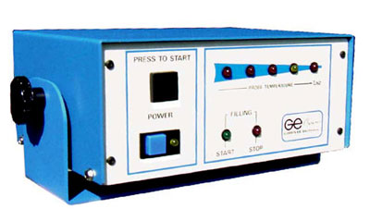
The Model 269 system allows the filling of a liquid nitrogen supply tank unattended. When the vent port manifold detects liquid nitrogen a shut-off valve is activated shutting off the supply of LN2 indicated by the audible horn and the lighting of the STOP LED.
The 269 is equipped with temperature status LED's indicating the progress of the filling cycle.

