Model 460
AUTO FILL CONTROLLER with HIGH AND LOW ALARM
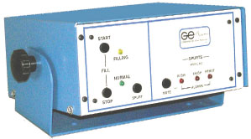
The Model 460 is a four (4) level liquid nitrogen controller, consisting of Low Level Alarm, Low Level Start Fill, High Level Stop Fill and High Level Alarm.
Both Ex-High and Ex-Low Alarms are indicated by a bright RED LED and an Audible horn, along with a RED Remote Relay LED and a Remote Alarm relay function. The last two (2) stages are the START and STOP fill functions indicated by the bright YELLOW Fill LED and the GREEN Normal (STOP FILL) LED. 117 volt AC (Option 220 volt AC)

