Model 600
HIGH OR LOW LEVEL ALARM
FEATURES:
• High or Low Level Alarm (selectable)
• Manual Fill Switch
• Mute Button
• Remote Relay
• Press to Test Remote Relay
• Press to Test Alarm
• 117 volt AC (220 volt option)
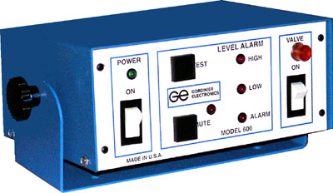
Model 600 has been designed to provide complete level protection. The unit may be used as a High Level over-fill or a Low Level alarm. It is equipped with both visual and audible indication, a Remote Alarm output and Manual Fill circuit. Included with this unit is a one (1) sensor probe, and a remote connector. (Valve and transfer hose not included)

