Model 670
HIGH LEVEL ALARM
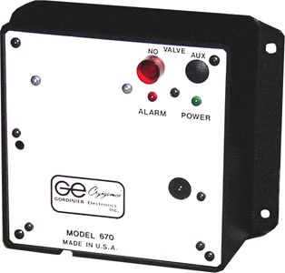
THEORY OF OPERATION:
Model 670 is a independent, self-contained, 117/220 volt, extra high level shut-off alarm system.
The Model 670s' thermistor sensor probe is placed above the storage tanks normal high level stop fill point. If filling continues past this point, the liquid nitrogen will advance to the Model 670 sensor, activating its audible horn, flashing LED and remote relay circuits. An additional power relay is activated to power a second normally open supply valve. This valve is placed in line with the storage units fill valve, providing another shut-off point.
This system is very important when a bulk tank is used in the filling process.
When the Model 670 is in place, other safety features insure proper functions:
1. Unplugging sensor probe or broken probe will activate complete system. (example): horn, remote relay and power relay will activate
2. Remote relay activates if Model 670 is unplugged from the wall.
3. Test Button: a small flush-mounted push-to-test button is provided, allowing periodically testing of the system.

